**ATAR course examination, 2020 Question/Answer booklet**

**APPLIED INFORMATION TECHNOLOGY**

Please place your student identification label in this box

Student number: In figures

|  |  |  |
| --- | --- | --- |
|  |  |  |

|  |  |  |
| --- | --- | --- |
|  |  |  |

In words

# Student Name: _______________________________

# Time allowed for this paper

Reading time before commencing work: ten minutes Working time: three hours

# Materials required/recommended for this paper

***To be provided by the supervisor*** This Question/Answer booklet Multiple-choice answer sheet

***To be provided by the candidate***

Standard items: pens (blue/black preferred), pencils (including coloured), sharpener, correction fluid/tape, eraser, ruler, highlighters

Special items: nil

# Important note to candidates

No other items may be taken into the examination room. It is **your** responsibility to ensure that you do not have any unauthorised material. If you have any unauthorised material with you, hand it to the supervisor **before** reading any further.

Copyright © School Curriculum and Standards Authority 2020 Ref: 20-006

**APPLIED INFORMATION 2**

**TECHNOLOGY**

**Structure of this paper**

|  |  |  |  |  |  |
| --- | --- | --- | --- | --- | --- |
| Section | Number of questions available | Number of questions to be answered | Suggested working time  (minutes) | Marks available | Percentage  of  examination |
| Section One  Multiple-choice | 15 | 15 | 20 | 15 | 15 |
| Section Two  Short answer | 8 | 8 | 50 | 70 | 25 |
| Section Three  Extended answer | 1 | 1 | 40 | 43 | 20 |
| Section Four  Scenario | 1 | 1 | 70 | 78 | 40 |
|  |  |  |  | **Total** | 100 |

**Instructions to candidates**

1. The rules for the conduct of the Western Australian external examinations are detailed in the *Year 12 Information Handbook 2020: Part II Examinations.* Sitting this examination implies that you agree to abide by these rules.
2. Answer the questions according to the following instructions.

Section One: Answer all questions on the separate Multiple-choice answer sheet provided. For each question, shade the box to indicate your answer. Use only a blue or black pen to shade the boxes. Do not use erasable or gel pens. If you make a mistake, place a cross through that square, then shade your new answer. Do not erase or use correction fluid/tape. Marks will not be deducted for incorrect answers. No marks will be given if more than one answer is completed for any question.

1. Write your answers to the questions in Sections Two, Three and Four in this Question/Answer booklet.
2. You must be careful to confine your answers to the specific questions asked and to follow any instructions that are specific to a particular question.
3. Supplementary pages for planning/continuing your answers to a question are provided at the end of this Question/Answer booklet. If you use these pages to continue an answer, indicate at the original answer where the answer is continued, i.e. give the page number.

**See next page**

**Section One: Multiple-choice 15% (15 Marks)**

This section has **15** questions. Answer **all** questions on the separate Multiple-choice answer sheet provided. For each question, shade the box to indicate your answer. Use only a blue or black pen to shade the boxes. If you make a mistake, place a cross through that square, then shade your new answer. Do not erase or use correction fluid/tape. Marks will not be deducted for incorrect answers. **No marks** will be given if **more than one** answer is completed for any question.

Suggested working time: 20 minutes.

1. Physical security measures for networks does not include:

1. alarms
2. locks
3. passwords
4. surveillance

2. The Freedom of Information Act (FOI) 1982 allows individuals to access information about them held by:

1. all Australian Government ministers and most agencies
2. all Australian Government agencies

(c) all Australian and International companies and Australian Government agencies

(d) all Australian companies and Australian Government agencies

3. One advantage of virtual collaboration is:

1. productivity will be minimally impacted if the network is faulty
2. pooling of expertise without the restriction of physical proximity
3. meetings are more hands on and personal, increasing engagement and understanding
4. social isolation is decreased

4. When creating a website, the people that can think from a user’s perspective to create and effective, polished website design that users can easily access and use are referred to as:

1. the User Interface (UI) engineers
2. the Graphic User Interface (GUI) testers
3. the User Experience (UX) designers
4. the Accessibility consultant

5. Which one of the following forms of security is a biometric technology?

(a) Wifi firewall software

(b) Encryption software

(c) Fingerprint scanner

(d) Username and password

6. Communication standard 802.11x is a specification for:

(a) an interface between two wireless clients on a LAN

(b) the physical media and characteristics of a LAN

(c) accessing information over a mobile wireless network

(d) the method of connecting hosts on the internet

7. A service-level agreement identifies:

(a) how to fix an issue with a client

(b) the amount of time needed to complete a job

(c) the contact details of the manager of the ICT support company

(d) the roles and responsibilities of service providers who support users

8. Many password systems allow a user a limited number of failed attempts before locking an account. How does this increase the security of the account?

(a) It forces the user to create a simple password

(b) It forces the user to think carefully before typing in the password

(c) It limits the number of times the user can login to the account

(d) It limits the opportunities for guessing a password

9. The Central Processing Unit (CPU) speed is measured in:

(a) gigabyte

(b) gigahertz

(c) terabyte

(d) binary

10. Which principle of design uses lines, shapes and colour to draw the viewer’s eyes through the image, often to a focal point?

(a) Balance

(b) Unity

(c) Movement

(d) Pattern

11. When creating headings for web publishing, which one of the following principles would be most significant?

(a) Contrast

(b) Pattern

(c) Movement

(d) Texture

12. The criteria for critically analysing sources of information does not include:

(a) verifiability

(b) accuracy

(c) accessibility

(d) currency

13. The values, standards, and rules of behaviour of a company are usually laid out in:

(a) employees’ contracts

(b) occupational, health, and safety documents

(c) service level agreements

(d) the company’s code of conduct

14. Which combination of colours reflects a complimentary colour scheme?

(a) Red and Orange

(b) Red and Purple

(c) Red and Green

(d) Red and Blue

15. A differential backup technique captures only the changes made:

(a) within a day

(b) since the last end-of-day backup

(c) since the last incremental backup

(d) since the last full backup

**End of Section One**

Section Two: Short answer 25% (70 Marks)

This section has **eight (8)** questions. Answer **all** questions. Write your answers in the spaces provided.

Additional working space pages at the end of this Question/Answer booklet are for planning or continuing an answer. If you use these pages, indicate at the original answer, the page number it is planned/continued on and write the question number being planned/continued on the additional working space page.

Suggested working time: 50 minutes.

**Question 16 (15 marks)**

The coronavirus pandemic has moved life online with many organisations forced to shift from traditional office spaces to virtual collaboration to run their businesses.

(a) Describe **two** advantages of virtual collaboration. (4 marks)

(b) Describe **two** disadvantages of virtual collaboration. (4 marks)

(c) Explain how virtual collaboration is being used in education. (3 marks)

(d) Describe **two** implications of virtual collaboration in education. (4 marks)

**Question 17 (6 marks)**

Explain how HTML and CSS work together in web design. In your answer, expand the acronym for HTML and CSS.

**Question 18 (15 marks)**

(a) What is a Local Area Network? (2 marks)

(b) Draw a simple Local Area Network (LAN) for an office with **wireless connection** to the internet using only the components listed below. Label all components and devices in your diagram. (8 marks)

* Office server
* 2 desktop workstations
* 1 wireless laptop
* Wired printer
* Switch
* Router
* Modem

(c) Outline the purpose of each of the LAN components below: (5 marks)

Server:______________________________________________________________________

___________________________________________________________________________

Switch:______________________________________________________________________

___________________________________________________________________________

Router:______________________________________________________________________

____________________________________________________________________________

NIC: ________________________________________________________________________

____________________________________________________________________________

Modem:_____________________________________________________________________

____________________________________________________________________________

**Question 19 (12 marks)**

Service Level Agreements are a critical component of outsourcing contracts.

(a) Define what a Service Level Agreement is. (2 marks)

(b) Describe **two** features that a company needs to include in service level agreements in relation to the outsourcing IT services. (4 marks)

(c) Describe **three** benefits to a company as a result of outsourcing IT services. (6 marks)

**Question 20 (6 marks)**

Describe **three** key differences between HTTP and HTTPS as communication protocols.

**Question 21 (6 marks)**

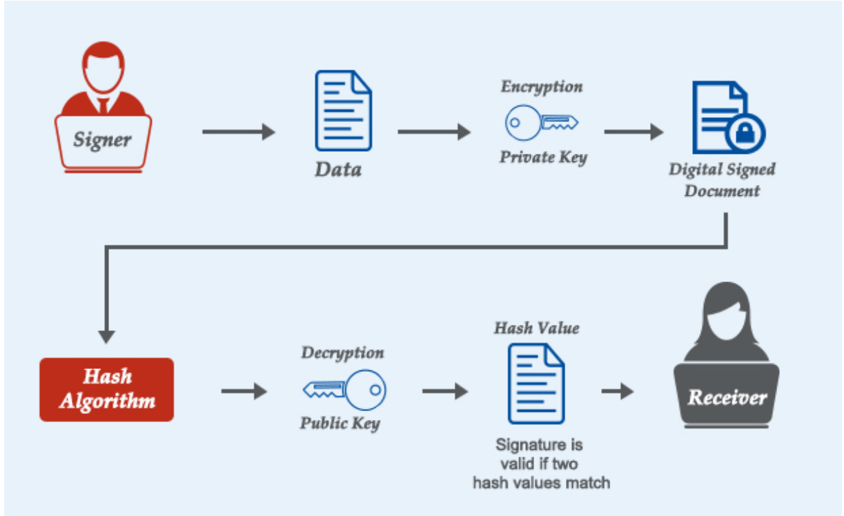

*https://comodosslstore.com/what-is-digital-signature.html*

The diagram above shows how a digital signature works.

(a) Use the diagram above to explain how a digital signature works. (4 marks)

(b) Describe the purpose of a digital signature. (2 marks)

**Question 22 (4 marks)**

Explain how data mining can be used in a supermarket to increase revenue.

**Question 23 (6 marks)**

Discuss **two** impacts Web 3.0 has on users of digital technologies.

**End of Section Two**

**Section Three: Extended answer 20% (43 Marks)**

This section contains **one (1)** question. Write your answers in the spaces provided.

Additional working space pages at the end of this Question/Answer booklet are for planning or continuing an answer. If you use these pages, indicate at the original answer, the page number it is planned/continued on and write the question number being planned/continued on the additional working space page.

Suggested working time: 40 minutes.

**Question 24 (43 marks)**

**Refer to the infographics and the article below to answer the questions that follow.**

**Secure, sustainable smart cities and the IoT**

**Smart cities** aren’t just a concept or a dream of the future.  Thanks to the wildly innovative Internet of Things (IoT) solutions, many are already active and expanding rapidly.

Municipal governments are leveraging cellular and Low Power Wide Area (LPWAN) wireless technologies to connect and improve infrastructure, efficiency, convenience, and quality of life for residents and visitors alike.

**What is a smart city?**

**A smart city is a framework**, predominantly composed of Information and Communication Technologies (ICT), to develop, deploy, and promote sustainable development practices to address growing urbanization challenges.

A big part of this ICT framework is essentially an intelligent network of connected objects and machines that transmit data using wireless technology and the cloud.

Cloud-based IoT applications receive, analyse, and manage data in real-time to help municipalities, enterprises, and citizens make better decisions that improve quality of life.

**Citizens** engage with smart city ecosystems in a variety of ways using smartphones and mobile devices, as well as [connected cars](https://www.thalesgroup.com/en/markets/digital-identity-and-security/iot/industries/automotive/connect-cars) and homes. Pairing devices and data with a city’s physical infrastructure and services can cut costs and improve sustainability.

**Communities** can improve **energy distribution**, streamline **trash collection**, decrease **traffic congestion,** and even improve **air quality** with help from the IoT.

For instance,

* Connected traffic lights receive data from sensors and cars adjusting light cadence and timing to respond to real-time traffic, thereby reducing road congestion.
* Connected cars can communicate with parking meters and electric vehicle (EV) charging docks and direct drivers to the nearest available spot.
* Smart garbage cans automatically send data to waste management companies and schedule pick-up as needed versus on a pre-planned schedule.
* And a citizens’ smartphone becomes their mobile driver’s license and ID card with digital credentials, which speeds and simplifies access to the city and local government services.

Together, these smart city technologies are optimizing infrastructure, mobility, public services, and utilities.

​​**How is IoT technology making cities smarter and better?**

Secure wireless connectivity and IoT technology are transforming traditional elements of city life - like streetlights - into next-generation intelligent lighting platforms with expanded capabilities.

The scope includes integrating solar power and connecting to a cloud-based central control system that connects to other assets in the ecosystem.

These solutions shine far beyond simple lighting needs.

* High-power embedded LEDs alert commuters about traffic issues, provide severe weather warnings, and provide a heads up when environmental issues like fires arise.
* Streetlights can also detect free parking spaces and EV charging docks and alert drivers where to find an open spot via a mobile app. Charging might even be able from the lamppost itself in some locations!

**What makes smart cities successful?**

In addition to people, dwellings, commerce, and traditional urban infrastructure, there are three essential elements necessary for thriving smart cities:

1. **Pervasive wireless connectivity**
2. **Open data**
3. **Security you can trust in**

Let’s break it down.

## What’s the best wireless technology for smart cities?

The first building block of any smart city application is reliable, pervasive wireless connectivity.

While there’s no one-size-fits-all, evolving Low Power Wide Area Network (**LPWAN**) technologies are well suited to most smart city applications for their cost efficiency and ubiquity.

These technologies include LTE Cat M, NB-IoT, LoRa, Bluetooth, and a few others that all contribute to the fabric of connected cities.

The advent of 5G technology is expected to be a watershed event that propels smart city technology into the mainstream and accelerates new deployments.

But only with a few more elements…

## Opening the data vault

Historically, governments, enterprises, and individuals have held their data close to the pocket, sharing as little as possible with others.

**Privacy** concerns and fear of security breaches have far outweighed the perceived value of sharing information.

However, a key enabler of sustainable smart cities is that all participants in the complex ecosystem **share information and combine it** with contextual data that is analysed in real-time. This is how informed decisions are made in real-time. So, how do we keep data private from the masses while sharing it among stakeholders?

**Can smart cities be secured and trusted?**

Connected cameras, intelligent road systems, and public safety monitoring systems can provide an added layer of protection and emergency support to aide citizens when needed.

* But what about protecting smart cities themselves from vulnerabilities?
* How can we defend against hacking, cyber-attacks, and data theft?
* In cities where multiple participants are sharing information, how do we trust that participants are who they say are?
* And how do we know the data they report is true and accurate?

The answers lie in physical data vaults and strong authentication and ID management solutions.

Smart cities can only work if we can trust them.

**Four core security objectives**

All ecosystem partners - governments, enterprises, software providers, device manufacturers, energy providers, and network service providers - must do their part and integrate solutions that abide by four core security objectives:

1. **Availability:** Without actionable, real-time, and reliable access to data, the smart city can’t thrive. How information is collected, distilled, and shared is critical, and security solutions must avoid negative effects on availability.
2. **Integrity:** Smart cities depend on reliable and accurate data. Measures must be taken to ensure that data is accurate and free from manipulation.
3. **Confidentiality:** Some of the data collected, stored, and analysed will include sensitive details about consumers themselves. Steps must be taken to prevent unauthorized disclosure of sensitive information.
4. **Accountability:** Users of a system must be responsible for their actions. Their interactions with sensitive systems should be logged and associated with a specific user. These logs should be difficult to forge and have reliable integrity protection.

To achieve these security core objectives, strong authentication and ID management solutions need to be integrated into the ecosystem to ensure that data is shared only with authorized parties. The solutions also protect backend systems from intrusion and hacking.

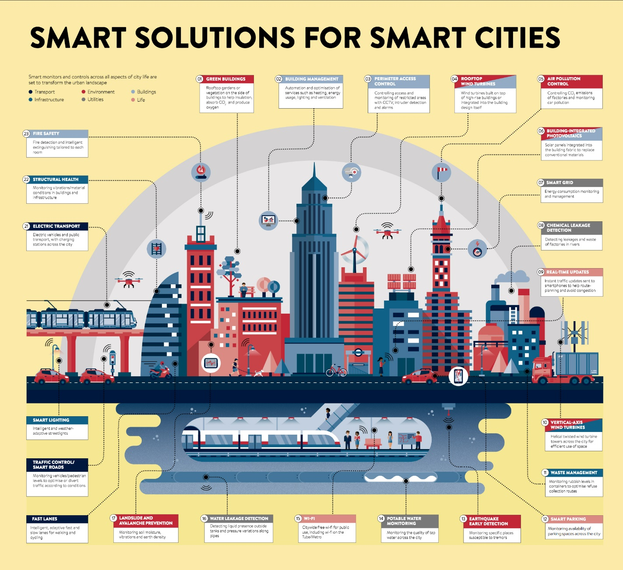

*Ref:* [*https://www.thalesgroup.com/en/markets/digital-identity-and-security/iot/inspired/smart-cities*](https://www.thalesgroup.com/en/markets/digital-identity-and-security/iot/inspired/smart-cities)

(a) Cloud-based IoT applications receive, analyse, and manage data in real-time to help municipalities, enterprises, and citizens make better decisions that improve quality of life. Some of the data collected will include sensitive details about citizens. This in turn raises concerns about privacy and security issues.

Describe **three** types of sensitive information. (6 marks)

(b) Describe **two** privacy concerns with the use of cloud based IoT technologies. (4 marks)

(c) Describe **two** security issues that may arise with Smart City technologies. (4 marks)

(d) Describe **three** network security measures that can help prevent these issues. (6 marks)

(e) Describe **three** devices using Internet of Things (IoT) technology that are evident in the infographics. (6 marks)

(f) Explain **three** ways in which wireless technologies are being used to connect and improve infrastructure, efficiency, convenience and quality of life for residents and visitors alike. Support your responses with reference to the article and infographics above. (9 marks)

(g) Explain why the following two essential elements are necessary for thriving smart cities:

**(8 marks)**

**Pervasive wireless connectivity:____________________________________________________ _______________________________________________________________________________________________________________________________________________________________________________________________________________________________________**

**_____________________________________________________________________________**

**_____________________________________________________________________________**

**_____________________________________________________________________________**

**_____________________________________________________________________________**

**Open sharing of data and information:_______________________________________________ _______________________________________________________________________________________________________________________________________________________________________________________________________________________________________**

**_____________________________________________________________________________**

**_____________________________________________________________________________**

**_____________________________________________________________________________**

**_____________________________________________________________________________**

**End of Section Three**

**Section Four: Scenario 40% (78 Marks)**

This section contains **one (1)** question. Write your answers in the spaces provided.

Additional working space pages at the end of this Question/Answer booklet are for planning or continuing an answer. If you use these pages, indicate at the original answer, the page number it is planned/continued on and write the question number being planned/continued on the additional working space page.

Suggested working time: 70 minutes.

**Question 25 (78 marks)**

The COVID -19 pandemic has caused a number of issues in the community including people who are struggling to put food on the table for their families. The Charities Organisation has asked you to create **a food sharing website and app** to help with the sharing of food by connecting neighbours with neighbours and businesses with charitable organisations. Everything on the website and app will be available for free. They have decided to call their business and app **Foodfulness**.

People and businesses can add items to the website and app by simply taking a photo of the item, adding a brief description and providing pick-up details which can be on the doorstep or a public location. They will get notified when they have a request and can check the user’s profile and star rating and then choose who to share with. They are encouraged to rate users after the meet. And can also report or block users.

People requesting items can browse what is available near them and arrange a pick-up. Volunteers will also be able to arrange pickup and safely redistribute the surplus food to local communities.

Whether it’s a caterer, restaurant, office, retailer or any other food business, the website and app should provide a sustainable solution to their business to reduce food waste and build food sharing communities.

**Requirement 1: Create the website (homepage)**

Create a website (homepage) that will include the following:

* About
* Log in
* How to share the food
* How to request the food
* Volunteers
* Link to get the app from the App Store and Google Play
* FAQS
* Search tool
* Videos

1. Explain how you will use the following **three** project planning tools to assist with the development of the digital solution for this project. (9 marks)

Gantt Chart: ______________________________________________________________

Storyboard:

Project Management Software:

1. Explain how you intend to incorporate the concepts listed below into the appearance of your website (homepage). (9 marks)

Structure:

Usability:

User interface:

(c) Describe the purpose of the World Wide Web Consortium (W3C) when designing your website (homepage). (2 marks)

(d) Explain how your digital solutions will comply with the following W3C standards for Web Design and Applications:

(9 marks)

Accessibility:

Internationalisation:

Graphics:

(e) Describe **two** features that you could incorporate into your digital solution to facilitate user-generated content. (4 marks)

(f) Design the website homepage for Foodfulness in the space provided below.

Your design must include annotations and show the following:

1. Layout and structure of your intended design (5 marks)
2. Elements and principles of design used and the relationship between them

(6 marks)

1. Organisation of content suitable for the given digital medium (3 marks)
2. Navigation controls suitable for the given medium (3 marks)
3. User-generated content feature/s suitable for the given digital medium (3 marks)
4. One accessibility feature (3 marks)
5. One usability feature (3 marks)

|  |
| --- |
| Planning: anything written on this page will **not** be marked. |

Use the surrounding area for annotations.

Extra space if needed.

**Requirement 2: Create an App**

(g) For the Foodfulness App creation, design the following **two** pages:

* **Landing page: Discover free food near you**

Include the following: Listings of food, Distance (how near item is), First name of person listing

Add item, Browse, Profile, more

* **Adding the item you want to share**

Include the following: Photo of item, description, pick up details, message me, time since posting, submit

Add item, Browse, Profile, more

For each of the **two** designs, include annotations and show the following over the next **two** pages:

1. Layout and structure of your intended design (10 marks)

1. Organisation of content suitable for the given digital medium (6 marks)

Use the surrounding area for annotations

**Landing page: Discover free food near you**

**End of questio**

Use the surrounding area for annotations

**Adding the item you want to share**

(h) Explain how you will use **one** technique to evaluate the effectiveness of your digital solution in accordance with the design brief. (3 marks)

**End of questions**

Question number:

Question number:

Question number:

Additional working space

Question number:

Additional working space.

Question number: